**Question 1**

James has a ticket for a football match in Sydney for which he paid $45. On the day of the game he takes the train to Sydney Olympic Park, which costs him $3. When he arrives, he realizes that the game is taking place in Moore Park instead. He can take a taxi for $50 and arrive just in time for the match. Otherwise, he will miss it. Suppose James values watching the match at $70. Should he take the taxi or go home?

**Answer:**

The costs of the ticket and the train are sunk(James cannot get them back no matter what he decided to do),so they should have no effect on his decision.This means that James must decide if the benefits of going to the concert($70) is greater than the $50 cab fare.

Take the taxi

**Question 2**

Jeff has a job working in a grocery store that pays him $5,000 per month, but he is thinking of quitting to open a café. He can rent the location he prefers, which includes furniture, for $3,000 per month and the kitchen equipment for $2,000 per month. He will manage the cafe and prepare all the food, but he must hire a server for $150 per day. He estimates that he must buy $500 in food supplies per day, and water and utilities will cost $30 per day when the café is open.

A. What is Jeff’s total fixed cost for a month?

B. Which of Jeff’s monthly costs are sunk?

C. Suppose that Jeff expects total sales to equal $900 per day. Should he open the café?

D. Suppose Jeff were made redundant at his current job. Would this affect his decision?

**Answer:**

1. If the time frame is a month,Jeff’s fixed costs include the opportunity cost associated with not working in his current job and renting the promises and equipment for the cafe.Thus,his total monthly fixed cost is $10000.

Total Fixed Cost=$5000+$3000+$2000=$10000

1. All of Jeff’s monthly fixed costs are likely sunk.
2. The marginal cost of operating the cafe for a day is $680($150+$500+$30)

31-day month : revenues=$900*31=$27900

Total costs=$10000+31*$680=$31080

Not open

1. A significant portion of Jeff’s fixed cost is his opportunity cost associated with quitting his job. If he were made redundant this would reduce his opportunity cost by reducing the value of his next best option. Since he would have been earning a loss equal to $3,180 per month before ($31,080 - $27,900), if the value of his next best option falls by more than this amount, then he should open the cafe. For example, this would be the case if his next best option were to be unemployment and collecting $1,500 per month in benefits.

**Question 3**

Penelope works part-time at a hair salon and earns $15 per hour. She also works as a bicycle messenger, where she earns $20 for every package she delivers. The table below lists the total hours she spends delivering packages.

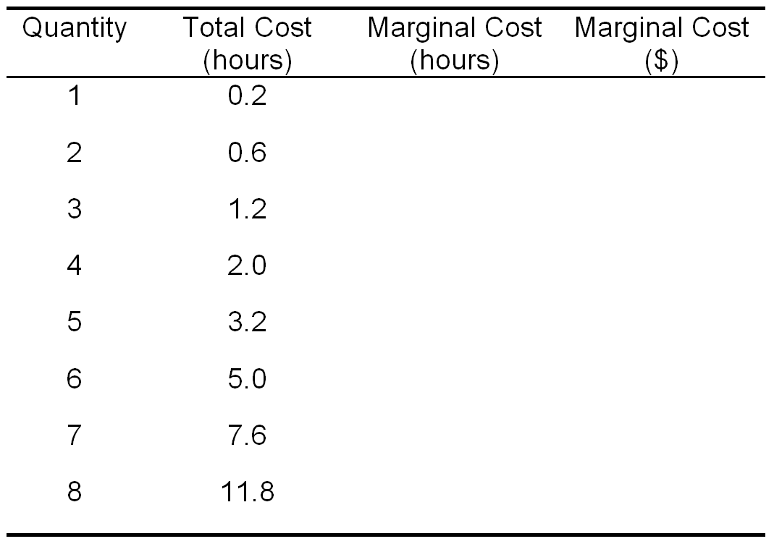

0.2 3

0.4 6

0.6 9

0.8 12

1.2 18

1.8 27

2.6 39

4.2 63

A. Fill in the table, calculating Penelope’s marginal cost of delivering each package measured both in hours and in forgone earnings.

B. In order to maximize her earnings, how many packages should she deliver?

C. Suppose that Penelope has to pay $30 per day to rent her bicycle. Should she continue to deliver packages every day?

**Answer:**

B. MC=$20,5 packages

C. Penelope’s total earnings from delivering packages is $100 per day (5x$20). Her opportunity costs are $30 for the bicycle and $48 in forgone earnings (3.2x$15), for a total of $78 per day. So, she should continue to deliver packages. Note that, because the rental cost is a fixed cost, it does not change the Penelope’s marginal cost or profit maximizing number of packages to deliver.

**Question 4**

The following table lists the costs of a production for a firm. Use it to answer the questions below.

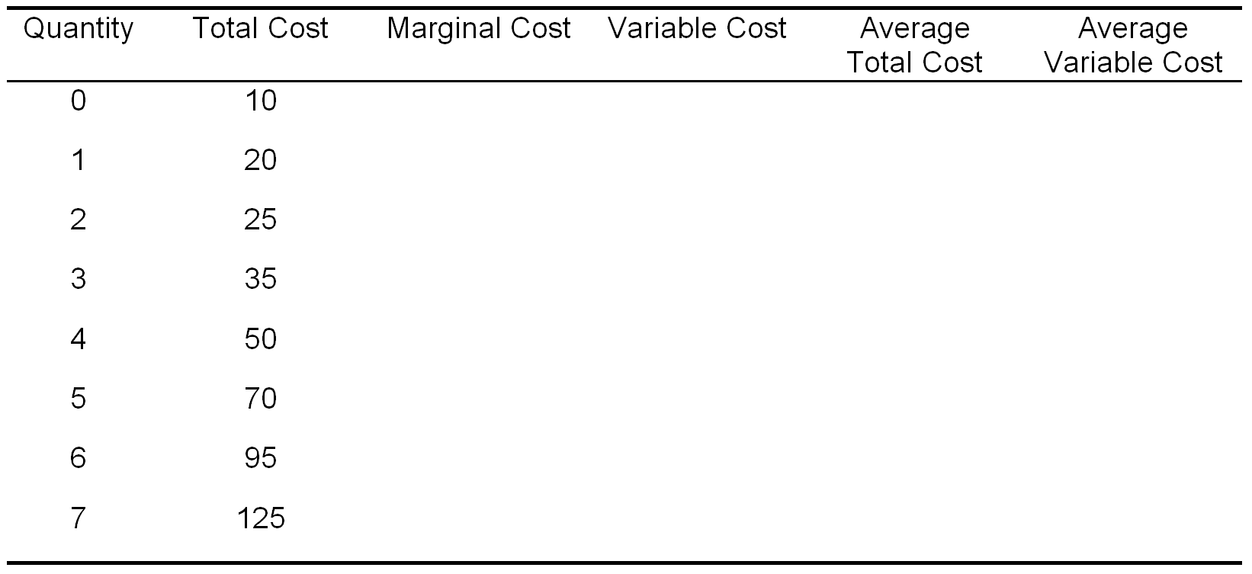

--- 0 --- ---

10 10 20 10

5 15 12.5 7.5

10 25 11.67 8.33

15 40 12.5 10

20 60 14 12

25 85 15.83 14.17

30 115 17.86 16.42

A. Complete the table for this firm.

B. Draw the firm’s short-run supply curve.

C. Calculate the firms maximum profit if the firm can sell its output for $25 per unit.

**Answer:**

B.The short-run supply curve is the portion of the marginal cost curve that lies above the average variable cost curve.

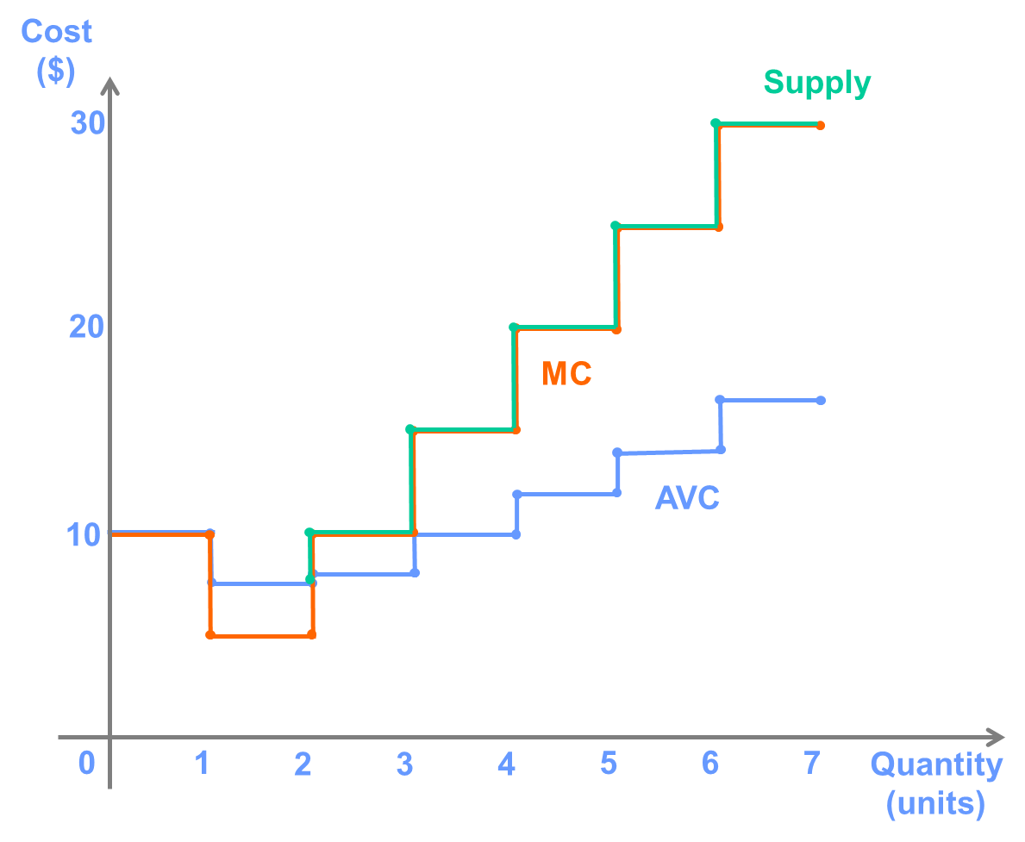

C. (MC<=MR , Q=6 ,maximum profit=55)The firms profit can be calculated as **Profit = Total Revenue - Total Cost**. At a price of $25/unit, the firm’s profit will be maximized by producing 6 units (recall the horizontal interpretation of the supply curve). Thus, total revenue is $150 ($25 x 6). The total cost of producing 6 units is $95, so the firm’s profit is equal to $55 ($150 - $95).

An alternative way to calculate the firm’s profit is to notice that profit is also equal to **Quantity x (Average Revenue - Average Total Cost)**. Since the price the firm receives does not depend on how much it produces (i.e., it is a “price taker”), average revenue is just equal to the price, which means that **Profit = Quantity x (Price - Average Total Cost)**. Using this calculation the firm’s profit is 6 x ($25 - $15.83) = $55.

The second method is useful because it allows us to show the amount of profit on the graph as the rectangle with height equal to (Price - ATC) and width equal to the quantity produced. In this example, this looks like the following:

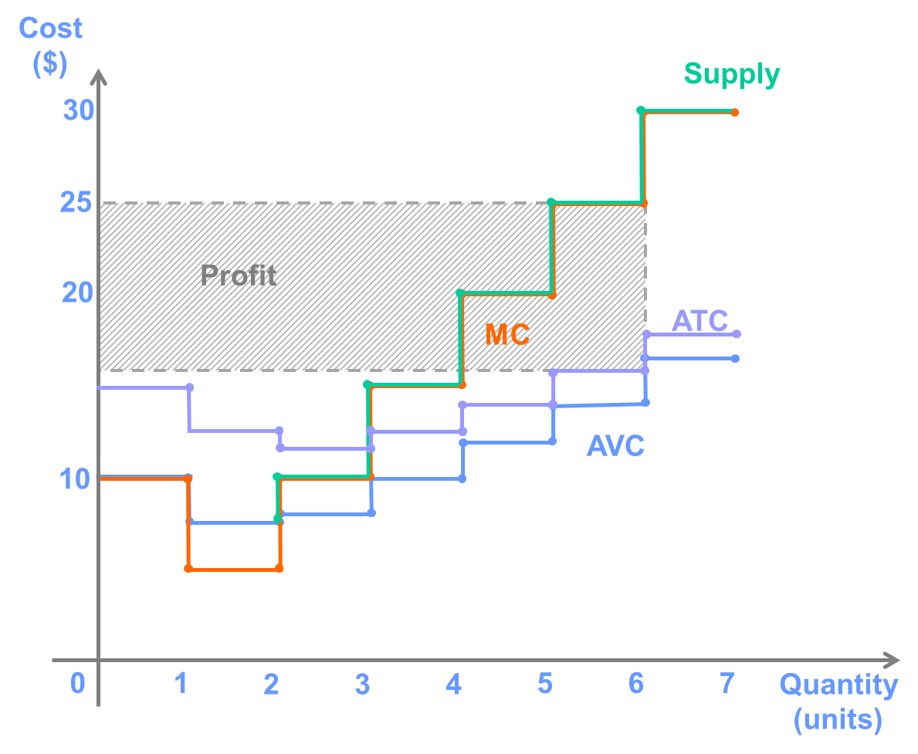

**Question 5**

Consider a firm with the following cost curves:

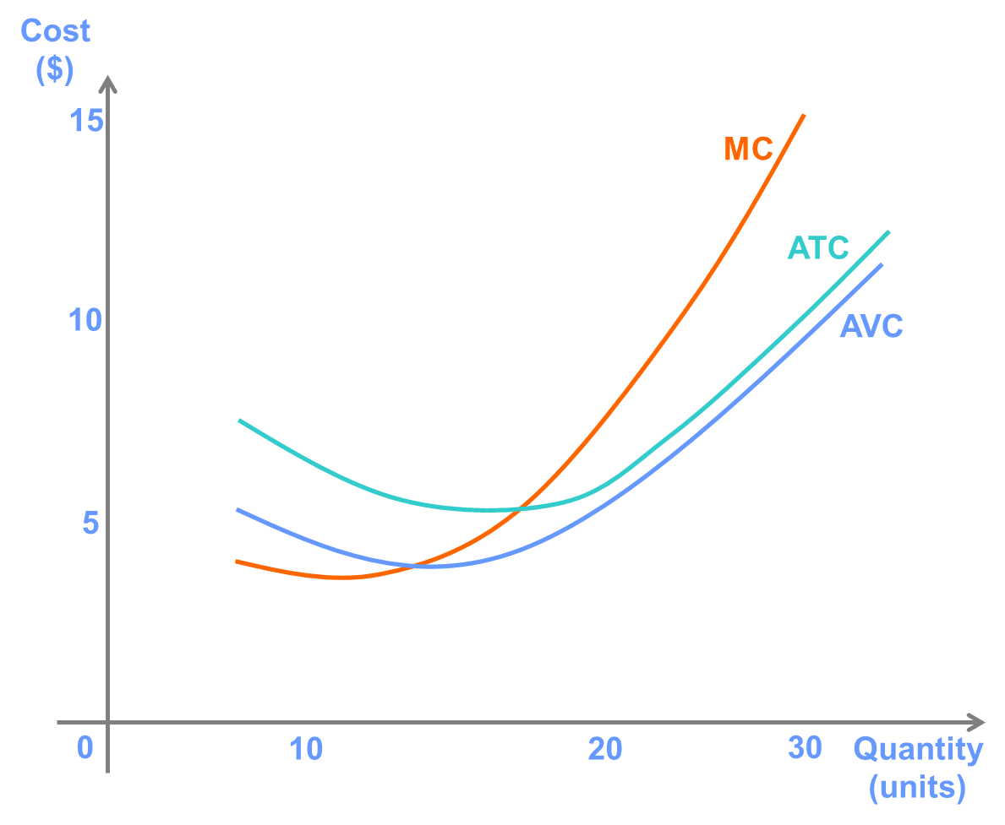

A. Using the graph, demonstrate how much the firm would produce if the market price were $10.

B. Based on this point on the graph, make a statement that demonstrates the horizontal interpretation of this firm’s supply curve and one that demonstrates the vertical interpretation.

C. On the graph, illustrate the profit earned by this firm at a market price of $10.

D. Suppose the market price changes to $8. Show on your graph how this will affect the firm’s profits.

E. Show on the graph a price for which this firm would continue operating in the short run but would exit the market in the long run.

**Answer:**

1. About 23 units
2. Horizontal interpretation:Given a price of $10,the firm will produce 23 units

Vertical interpretation:The firm’s reservation price(or marginal cost)for producing the 23rd unit is $10

D. At the lower price,the firm’s profit maximizing quantity and its profit decreases

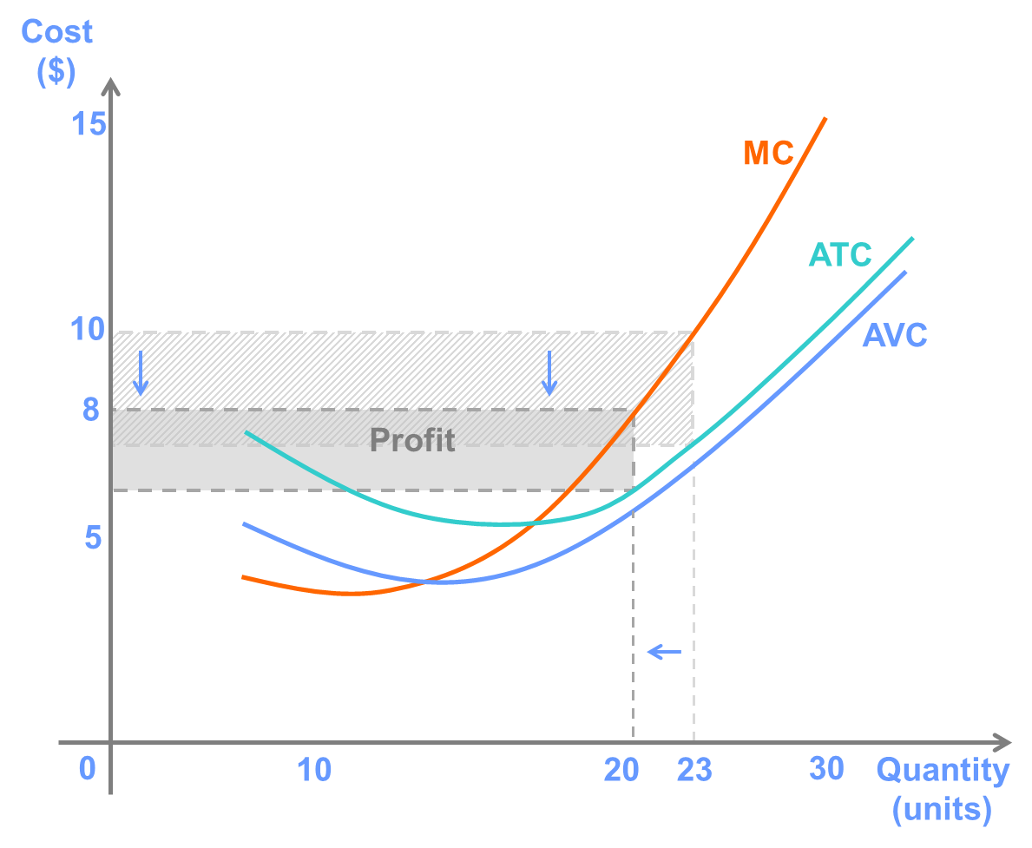

E. The firm will exit in the long run if it is earning a loss (P<ATC) but will continue operating the short run if the price is greater than average variable cost because this will allow the firm to cover some of its fixed costs.

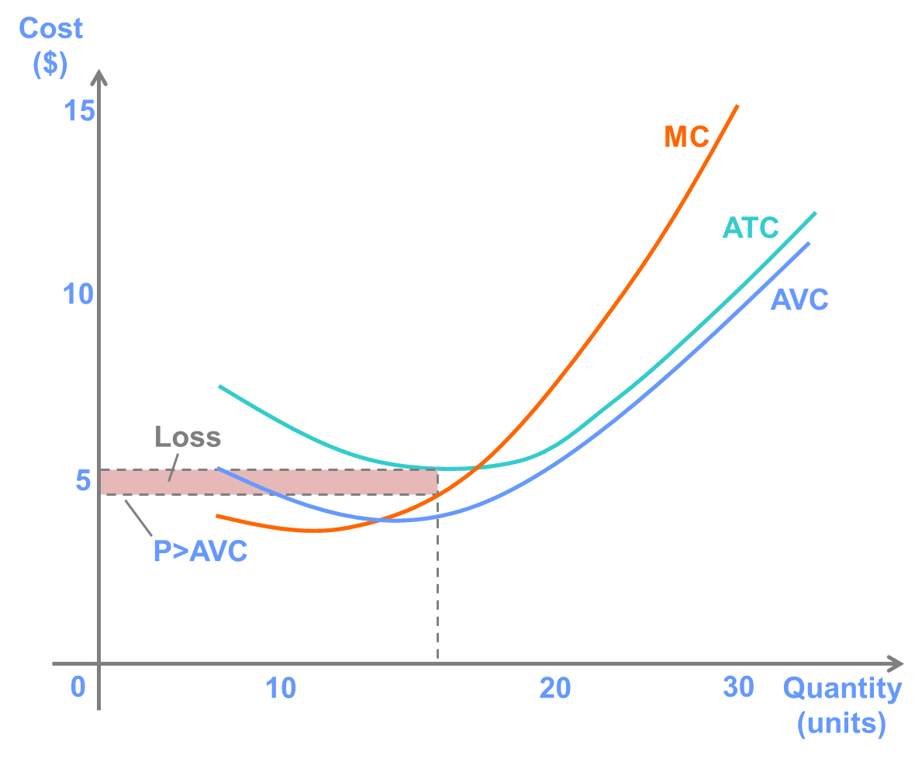

**Question 6**

Show on a graph and explain how each of the following scenarios is likely to affect the market supply for the product specified.

A. Oranges: The market price of oranges increases.

B. Automobiles: The price of steel decreases.

C. Bananas: A fungus infects banana trees.

D. Leather: The quantity supplied of beef increases.

**Answer:**

A. An increase in the price of oranges causes a movement along the supply curve. By the Law of Supply, an increase in the price of oranges causes an increase in the quantity supplied.

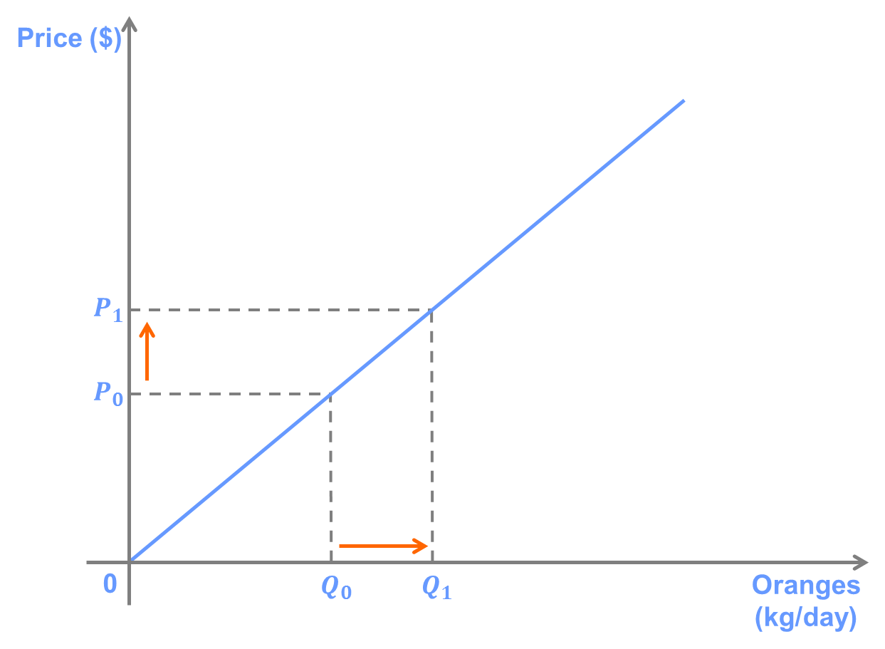

B.Because steel is an input in the production of automobiles, a decrease in the price of steel lowers the marginal cost of producing automobiles. According to the vertical interpretation of the supply curve, producers' reservation price for a given quantity supplied decreases. In terms of the horizontal interpretation, this means that, at a given price, producers are willing to supply a greater quantity of automobiles. This implies that the supply curve shift to the right.

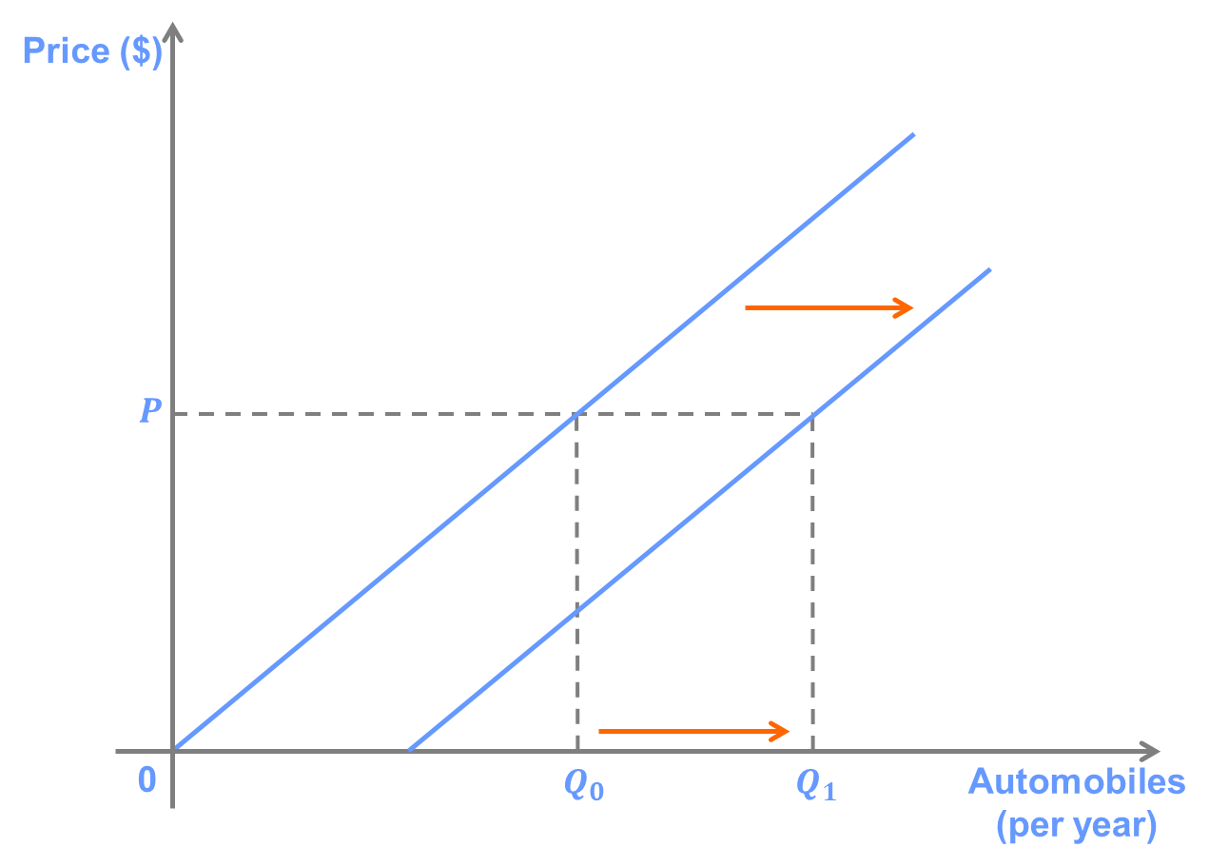

C.The fungus increases the marginal cost of producing bananas. Thus, producers will be willing to supply less at a given price, and the supply curve shifts to the left.

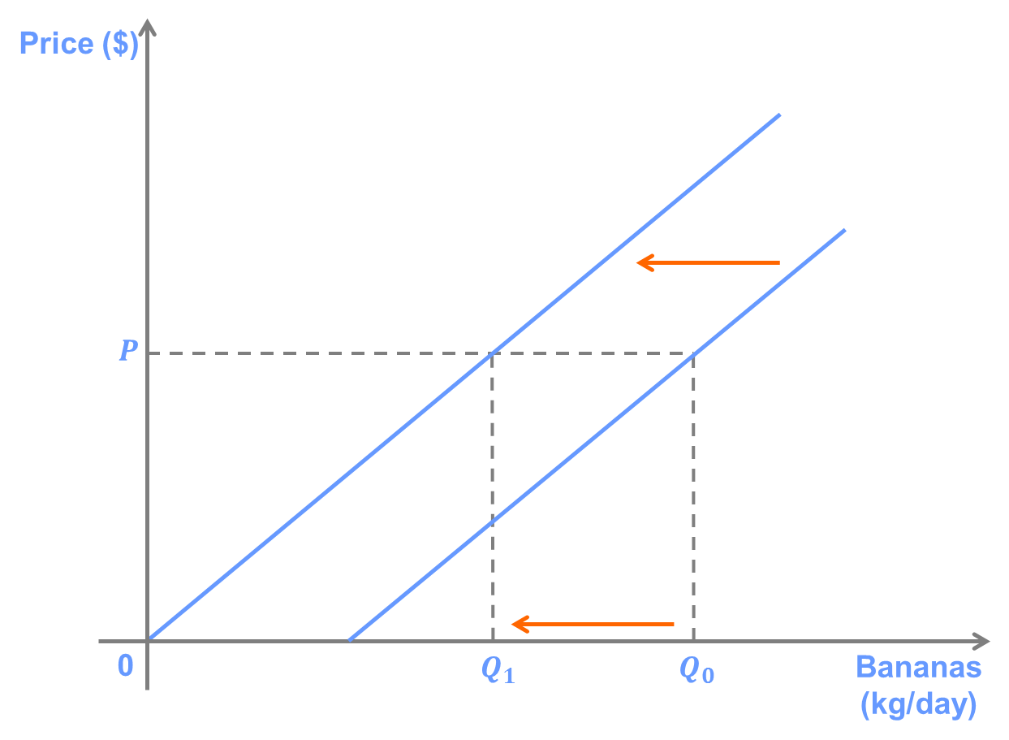

D.Beef and leather are complements in production. An increase in the quantity of beef supplies means that there are more cow hides available to be made into leather. This reduces the marginal cost of producing leather, which shifts the supply curve to the right, indicating an increase the quantity producers are willing to supply at a given price.

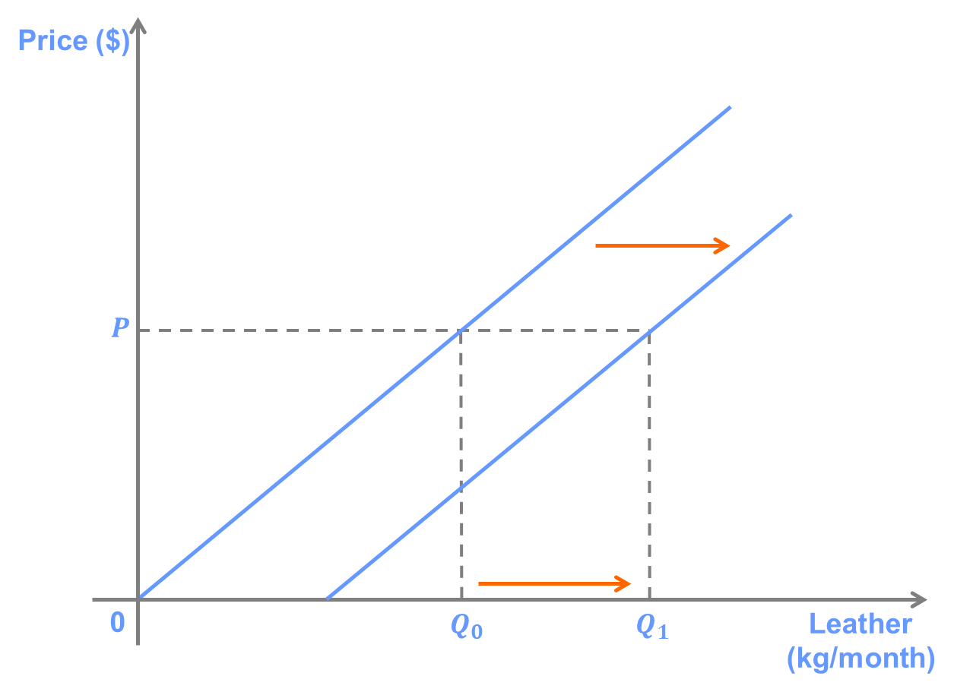

**Question 7**

Suppose that Sandy’s Sandwiches is a sandwich shop that has a supply curve which can be written as P = 2Q + 10.

A. Draw this supply curve on a graph.

B. Calculate the price elasticity of supply when P = $20 and when P = $30.

C. Give an example of something that would likely cause the price elasticity of supply for Sandy’s to increase (for a given quantity supplied).

**Answer:**

A.

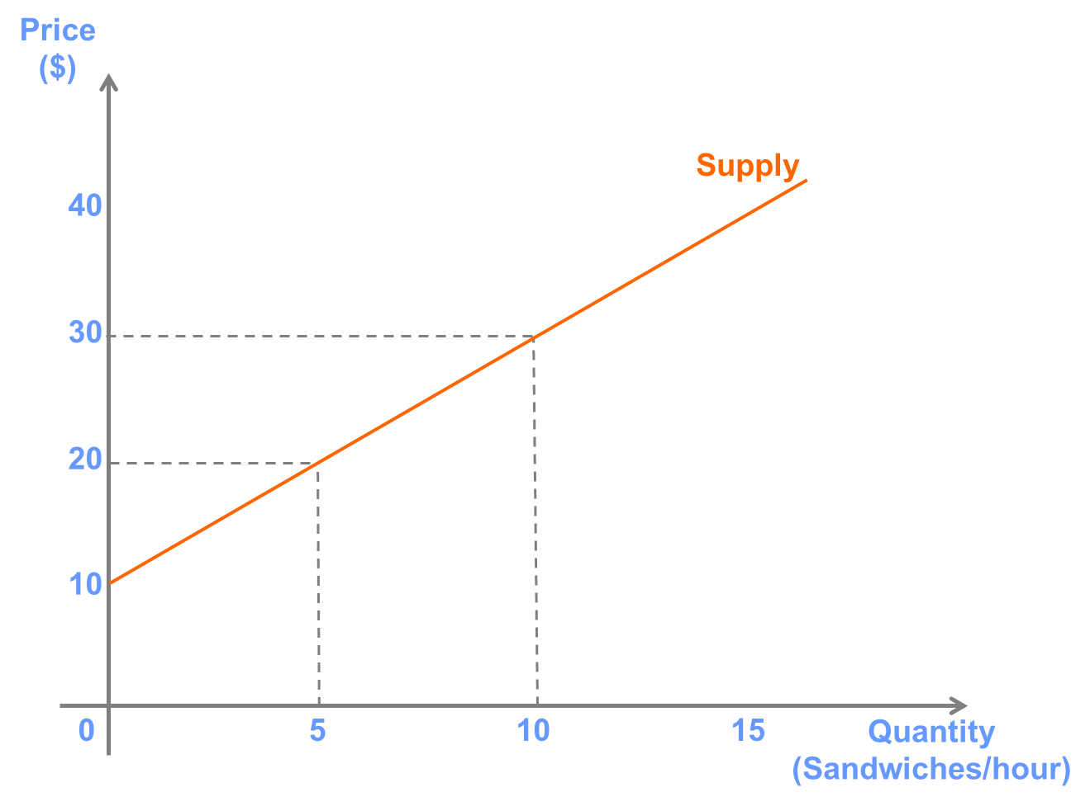

when p is subject=gradient/slope

B. The formula for elasticity is (P/Q)x(1/slope).

The price elasticity of supply at P=$20 (and Q = 5) is ($20/5)x(1/2) = 2.

The price elasticity of supply at P=$30 (and Q = 10) is ($30/10)x(1/2) = 1.5.

C.There are many factors that could cause the price elasticity of supply for Sandy’s to increase. Here are a few examples:

1. A bread supplier moving closer to the store location would make it easier to increase the number of sandwiches produced if demand is unexpectedly large one day.

2. If Sandy’s also begins producing salads, many of the same ingredients could be used for both salads and sandwiches. Because it would be easier to divert, say, lettuce from the production of salads to the production of sandwiches than to buy more lettuce from a supplier, it would easier to increase the number of sandwiches produced on a given day.

3. The time horizon considered also has a large influence on the price elasticity of supply. The elasticity for sandwiches produced per month is likely to be higher than the elasticity of sandwiches produced per day because it will be easier to change the number of sandwiches produced in response to a change in price, for example by hiring an additional worker.